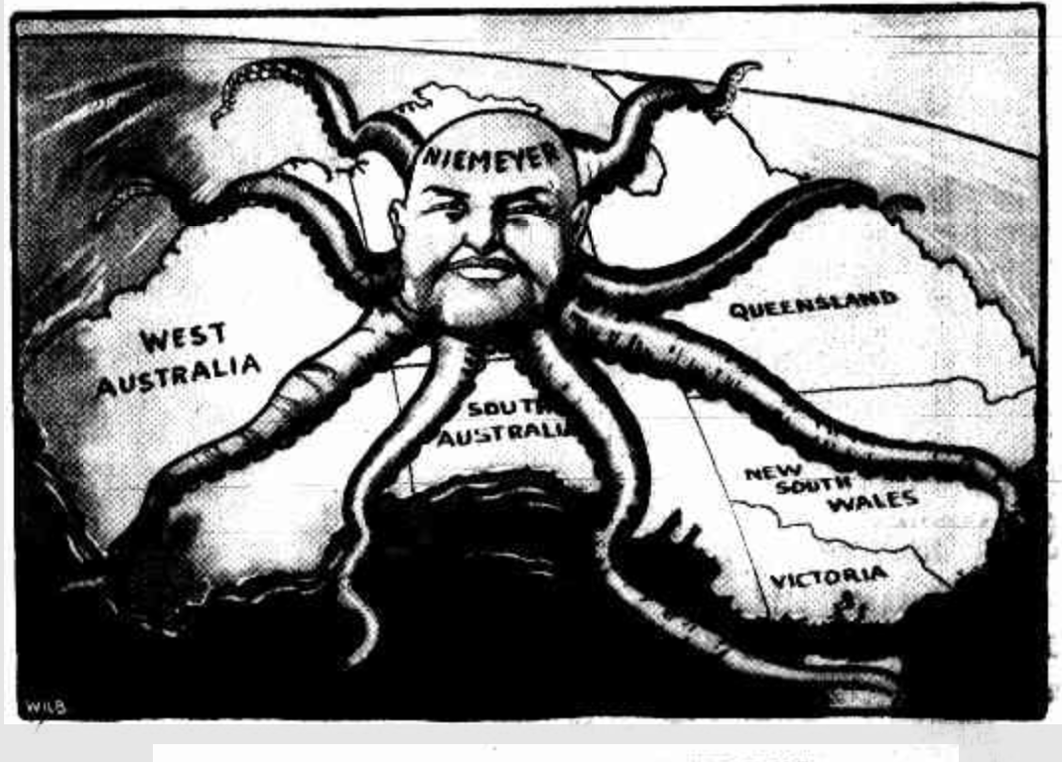
Source 1:

Cartoon published in the newspaper, Worker (Brisbane) on 27 August 1930.
Source 2:

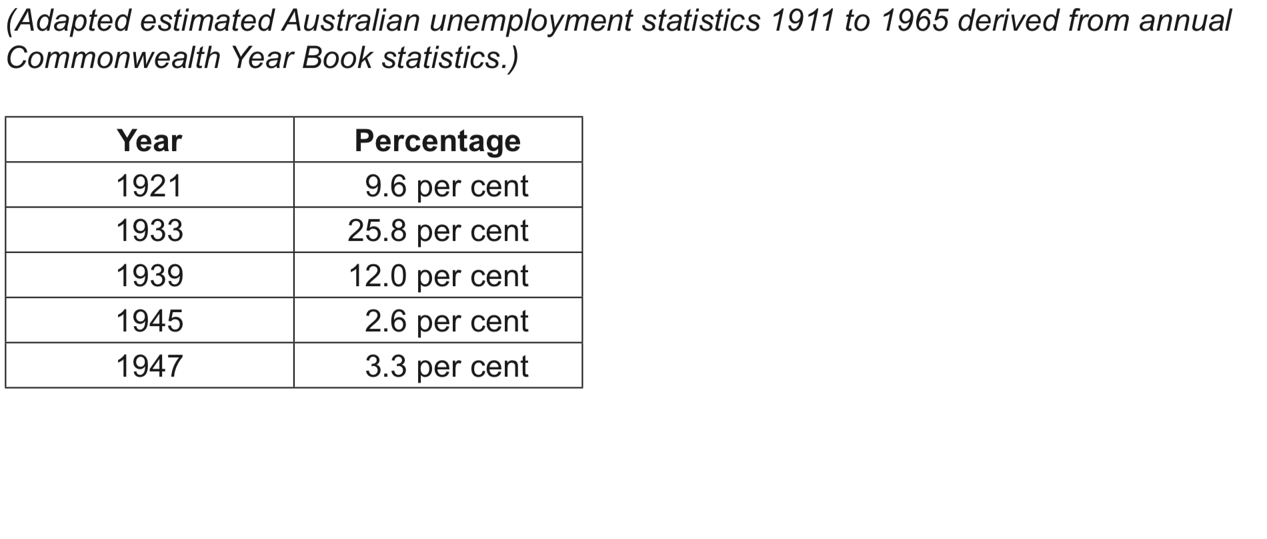

- Evaluate the usefulness, in terms of strengths and weaknesses, of Source 1 and Source 2 regarding the impact of the economic forces represented. (6 marks)

